Day 4: Booleans, logical operators and conditional statements
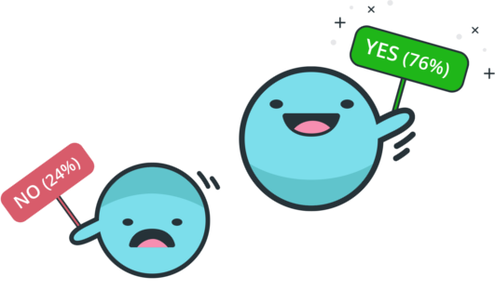

Start the lab
- As in previous labs, open a new terminal and run startlab
- Run idle3 &

Part 1. Types Practice
- Underline the right solution. Try it on your computers!
(True and False are both the boolean, 'bool', type.)
 |  | Underline One
 | 10 == 11 | True or False or Error
 | 'strings'=="strings" | True or False or Error
 | 'strings'=="strings' | True or False or Error
 | B == 10 = 5 | True or False or Error
 | A = 10 == 10 | True or False or Error
 | (5 > 0) == False | True or False or Error
 | (2 >= 9) <= (1 - 1) | True or False or Error

Part 2. Boolean Operators (Comparing Magnitude and Equality)
Ted was typing in the Python shell. His screen is printed below, with some parts missing.
Fill in the missing parts using ==, !=, >, <, =>, <=, or integers.
Check your answers in IDLE3. (There may be more than one correct answer!)

>>> 6 _==_ 7
False
>>> _0_ >= -1
True
>>> 'MEET' _==_ 'meet'
False
>>> "meet" _==_ 'meet'
True
>>> a = 3
>>> b = 10
>>> a*4 _>_ 2*b
False

Part 3. Conditional statement (if, elif, else) Practice
You learned about conditional statements if and else.
These let your program go in different directions when certain things are true.

With if and else, your program can go in two directions: one for the if case and one for the else case.

Open a new file and name it indentation.py that:

Try out the following code:

indentation = False

if indentation:
print('chocolate')
print('Indentations are cool!')

When you run the file what gets printed to the screen?

Identations are cool!

Change indentation from True to False. Now, what gets printed to the screen?

chocolate
Identations are cool!

Now change the code to this:

indentation = False

if indentation:
print('chocolate')
print('Indentations are cool!')

When you run the file what gets printed to the screen?

chocolate
Identations are cool!

What is the difference between the two codes?

The first code will print “Identations are cool!” no matter what, and the second code will print “Identations are cool!” only if identation = True.

Do you feel comfortable about indentations and code blocks now?

Yes

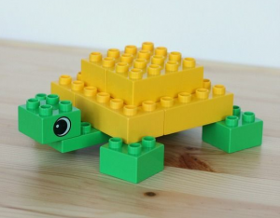

You are designing a fruit sorting robot for your local grocery store. Open a new file and name it fruit_sorter.py that:
- Takes in an input
- Assigns the fruit to the correct bin:
  - Apples in bin 1
  - Oranges in bin 2
  - Olives in bin 3
- If the input is none of the above your code should print: 'Error! I do not recognize this fruit!'

Here is an example of what your code would look like:

new_fruit = input('What fruit am I sorting?')

if _____________:
print('Bin 1')
elif ___________:
print('Bin 2')
else:
print('Error! I do not recognise this fruit!')

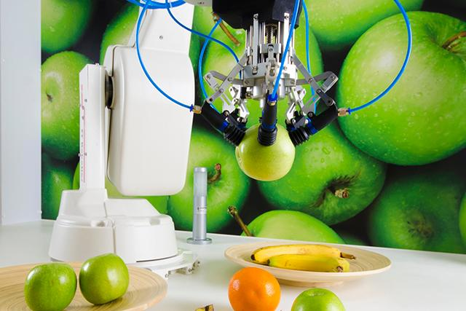

Let's try a problem! Open a new file and name it "turtle_party.py".

When turtles get together for a party, they like to have strawberries! But their strawberry parties have some rules:
- On a weekday, they want strawberries > 39 and strawberries < 61.
- On a weekend, they want strawberries > 39.
- Print 'Fun' or 'Not Fun' with the given values to show if the party was a success!

Help them to figure out if a party is going to be fun!

To get you started, here is part of the code you would need:

strawberries = 50
is_weekend = True

if _____________:
print('Not Fun!')
else:
print('Fun!')



What does Python print when we run turtle_party.py with these variable assignments?

# of strawberries | Is it a weekend? | Write what gets printed to the screen
strawberries=30 | is_weekend = False | Not Fun!
strawberries=50 | is_weekend = False | Fun!
strawberries=70 | is_weekend = True | Fun!
strawberries=30 | is_weekend = True | Not Fun!
strawberries=50 | is_weekend = True | Fun!
strawberries=60 | is_weekend = False | Fun!
strawberries=61 | is_weekend = False | Not Fun!
strawberries=40 | is_weekend = False | Fun!
strawberries=39 | is_weekend = False | Not Fun!
strawberries=40 | is_weekend = True | Fun!
strawberries=39 | is_weekend = True | Not Fun!

Survey Link: https://goo.gl/forms/GKrpIzXQnQN8m9ah2

Part 4. More practice with Conditionals
You are driving too fast and a police officer stops you! Write code to compute the result ('no ticket', 'small ticket', 'big ticket').
- If speed < 31, the result is 'no ticket'.
- If speed > 30 and speed < 51, the result is 'small ticket'.
- If speed > 50 result is 'big ticket'!
- Unless it is your birthday! On your birthday your speed can be 5 higher in all cases!

Open a new file and name it "caught_speeding.py". Your code should look something like this:

speed = 50
is_birthday = True

if _____________:
print('no ticket')
elif ____________:
print('small ticket')
else:
print('big ticket')



What does Python print when we run the caught_speeding.py code with these variable assignments:

Car speed | Is it your birthday? | What gets printed to the screen?
speed=30 | is_birthday = False | no ticket
speed=50 | is_birthday = False | small ticket
speed=70 | is_birthday = True | No ticket
speed=30 | is_birthday = True | No ticket
speed=50 | is_birthday = True | No Ticket
speed=60 | is_birthday = False | Big ticket
speed=61 | is_birthday = False | Big ticket
speed=40 | is_birthday = False | Small ticket

Compare script_a.py and script_b.py:

script_a.py:
num1 = ____
num2 = ____
num3 = ____

if num1 > num2:
print('chocolate')
elif num1 > num3:
print('vanilla')
else:
print('strawberry')

script_b.py:
num1 = ____
num2 = ____
num3 = ____

if num1 > num3:
print('chocolate')
elif num1 > num2:
print('vanilla')
else:
print('strawberry')

Do you think they should give the same answer when:
num1 = 2
num2 = 3
num3 = 1

Write your answer below and explain your reasoning.
Answer: No, because for example num1 (2) is bigger then num3 (1) but smaller then num2 (3), so the if staement is False in the first code (prints out vanilla) and True in the second one (prints out chocolate).

Copy script_a.py and script_b.py into two Python files. Run each on those same assignments
(num1 = 2 num2 = 3 num3 = 1). Were you correct? Are the answers the same? I was correct, the answers are not the same.

